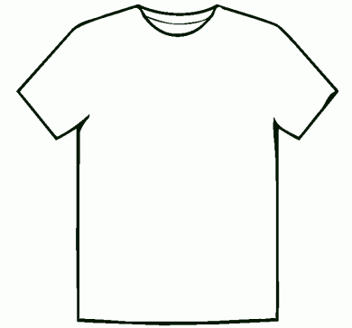

*Attention*
Please let us know what
size t-shirt your student
needs and we’ll put in the
order as soon as possible.

Circle ONE and return this
paper asap! Thank you!

Student’s Name ____________________

Small (6-8)
Medium (10-12)
Large (14-16)
XL (16-20)

